Crime and punishment in an era of extremism

By Alec D’Angelo

Over 600 Americans are currently being prosecuted for their role in the January 6th insurrection. Unlike previous cases of political terrorism, a sizeable portion of those prosecuted so far have been charged with misdemeanors or received alternatives to jail time such as probation. While many cases have yet to go to trial, a comparison with individuals prosecuted for attempting to travel overseas to join terrorist groups like ISIS reveals a stark contrast in criminal penalties.

The sentencing for travelling abroad to join jihadist groups held an average

of 14 or 10 years, depending on if they were successful. Many of those reported to have traveled abroad have died or their whereabouts are otherwise unknown. This creates challenges in comparing cases on top of differences in charges which yield differing minimum sentences. However, a comparison of their journeys, either abroad or to D.C. illustrates an interesting look at how the fates of those involved differed.

In 2014 Hamza Ahmed, Mohamed Farah, Zacharia Abdurahman and Hanad Musse devised a plan to travel from Minnesota to New York by bus, where they would then board flights to Istanbul. Their routes mirrored past successful trips made by Americans traveling abroad to join jihadist groups in Iraq and Syria. A fifth member of their cohort, Guled Omar, opted to travel to San Diego instead, seeing this as the better option. Authorities intercepted the travelers at their respective airports, though the men were ultimately released under strict surveillance. The group maintained their efforts to travel to Syria via Istanbul and were subsequently arrested during FBI operations that same year. Mohamed Farah’s brother Adnan attempted to join him, but his mother, noticing something awry, had hid his passport. Those that were arrested received sentences ranging from two and a half to 35 years in federal prison. The case of the Minnesotans reveals that one of the most common factors shaping one’s decision to join a jihadist group is whether one has any friends or family members who have done so. Guled Omar’s brother Ahmed Ali Omar had joined al-Shabaab in Somalia prior to Guled’s attempted travel. Abdi Nur traveled earlier that year and had posted about his experience online as well as maintained contact with friends in Minnesota.

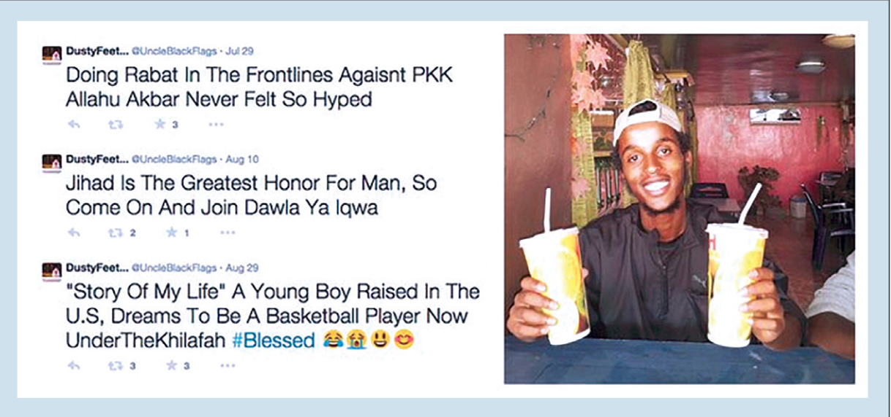

According to the GW Program on extremism, at least seven residents of the Minnesota Twin Cities area traveled to Syria and Iraq to fight between 2013 and 2017. Ten residents attempted to travel abroad but were unsuccessful. One of the first attempted travelers, Abdullahi Yusuf, now takes part in a program aimed towards rehabilitating jihadists and was granted supervised, conditional release in 2017.

GW’s institute on extremism tracked 83 cases in their report. These cases were overwhelmingly male, with an average age of 27. Minnesota, Virginia, and Ohio made up the most common states for travelers. According to the report, “At least 36 travelers are in foreign custody, at large, or their status and whereabouts are publicly unavailable.” Meanwhile, over 600 U.S. individuals are currently being prosecuted for their role in the January 6th attack. California, Florida, and Texas were the most common states for insurrectionists. While most of those prosecuted for their actions on January 6th still await sentencing, the current sentences appear to favor probation or other alternatives to jail time. Twice as many cases are pending as have been decided so far, meaning this is subject to change. The harshest sentences tended to fall on those charged with assaulting a police officer, or those being charged with conspiracy according to Seamus Hughes, president of GW’s Program on Extremism. Many of these cases have yet to reach trial as well, he said.

Washington resident Devlyn Thompson received 1,399 days, over 3 years, for his actions on January 6th. He agreed to plead guilty in his first court appearance without need for arrest or indictment, according to the Government Sentencing Memorandum.

Video from that day shows Thompson participating in violent encounters with Capitol Police and attempting to take officers’ riot shields to use against them. He is also seen trying to throw a speaker which strikes and injures a fellow rioter. He was ultimately charged for assaulting an officer with a police baton.



Texas resident Jennifer Leigh Ryan received 60 days for her actions. The Government Sentencing Memorandum stated that the harshest penalties were to fall on those who committed felonies and engaged in violence on January 6th, while those charged with misdemeanor trespass fell into two categories: “Those who trespassed, but engaged in aggravating factors, merit serious consideration of institutional incarceration, while those who trespassed, but engaged in less serious aggravating factors, deserve a sentence more in line with minor incarceration or home confinement.” they said. The memorandum states Ryan engaged in the former type of trespass, meriting her jail time. Ryan live-tweeted during the insurrection, stating in one tweet, “We just stormed the Capitol. It was one of the best days of my life.”

Travelers were charged on terror-related offences and thus received higher minimum sentences. Similarly, those prosecuted would face difficulties reintegrating into society upon release. In contrast, some insurrectionists may face no stigma going home, Hughes said. “If you joined ISIS and came back to Chicago after that and you went to your local mosque, they wouldn't very much want to hang out with you,” Hughes said, “whereas if you did the January 6 insurrection and you go back to your hometown in Texas, they may see you as a hero.” Hughes said this distinguishes January 6th from other terrorism cases and that such a comparison may be apples to oranges. However, this warrants renewed attention on who gets charged with 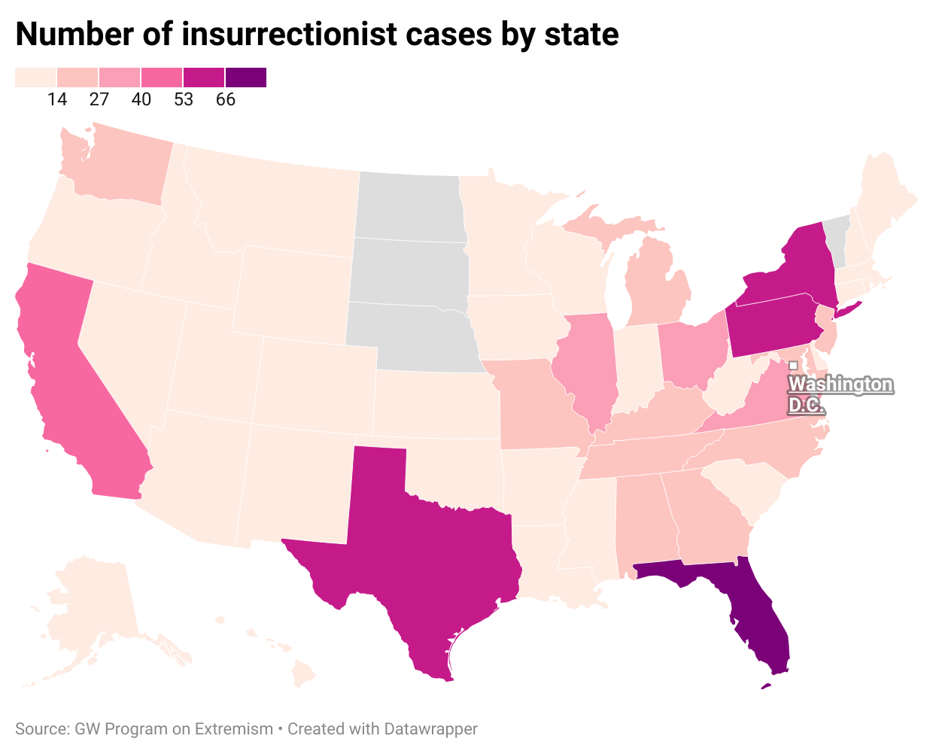terror-related offences and who goes home a hero.

Within both cases analyzed the subjects don’t appear in any monolithic manner. For both cases peer support seems to have a large influence when engaging in their respective crimes. Jenna Ryan from Texas tweeted after one of the rioters was shot by police saying she and her friends would remain, and that, “all my friends we are 100% we didn’t care we’re here for the USA. Give me liberty or give me death. No joke.” 213 individuals have pleaded guilty so far in connection with the January 6th insurrection. Both insurrectionists and travelers were overwhelmingly male. Interestingly, no cases have been reported on individuals from North or South Dakota, Nebraska, or Vermont. Hughes said he has no idea why this is. “I keep telling my Nebraska colleague that they got something in the water there. I don't know,” he said.

While larger sentences will likely appear as those bigger cases proceed to trial, early results show clear differences in how the justice system responds to extremism. Should those cases fail to provide proper punishment, the threat of those involved becoming emboldened grows. While the differences in sentences are the result of different statutory charges, it also reveals how such statutes risk classifying cases as terrorism only when they involve Muslim-Americans.